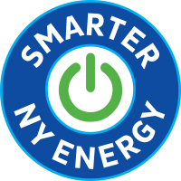

New York’s Energy Plans Could Prove Disastrous

Dear Friend,

Like many of you, we are concerned about climate change and support smart action to reduce carbon emissions. Unfortunately, NY’s proposed plans to “electrify everything” could prove disastrous.

Speak Up for Your Energy Future

The proposed climate action plans would fundamentally change how you heat your home, drive your car and cook your food. They will force you to switch to electric cars, heat pumps and stoves, no matter how much they cost or how poorly they perform. They would lead to extreme new “Carbon Taxes,” and send all energy prices soaring.

What’s more, the reliability of our electric grid could be severely compromised. New York already has the most power interruptions in the Mid-Atlantic. Transitioning to an all-renewable electric grid so quickly while vastly increasing electricity demand is downright dangerous.

It's Time to Make Your Voice Heard!

NY’s Climate Action Council is now accepting public comments on their proposed “scoping plans.” It’s time to say NO to higher energy costs, unreliable home heating and a dangerously overburdened power grid. We need an energy plan that doesn’t put all our eggs in one fragile, expensive electric basket.

Go to SmarterNYEnergy.org to learn more. If you agree these plans go too far, click on the TAKE ACTION button to make your voice heard.

Sincerely,

[signature here]

